**MONEFY APP**

1. **Exploratory Testing**

**Operating System:** Android

* *Charter 1*

Explore ‘expense’ functionality with various data sets and different options (create and edit) to discover how the ‘expense’ interface responds.

* *Charter 2*

Explore ‘income’ functionality with various data sets and different options (create and edit) to discover how the ‘income’ interface responds.

* *Charter 3*

Explore ‘language’ functionality using different languages to discover if the app is translated.

* *Charter 4*

Explore ‘accounts’ functionality using different operations (create, edit and delete) to discover how the ‘account’ interface responds.

* *Charter 5*

Explore ‘transfer’ functionality using different options to discover how the ‘transfer’ interface responds.

* *Charter 6*

Explore ‘calendar’s’ filter using various data sets and different values to discover how ‘calendar’s’ filter interface responds.

* *Charter 7*

Explore ‘search’ option using various data sets to discover how ‘search’ interface responds.

1. **Findings**
2. **Scenario:** ‘Account was updated’ successfully message in ‘accounts’ option

***Title:*** ‘Account was updated’ successfully message is displayed when ‘back’ icon is clicked

***Steps:***

**Given** the user access to the ‘Monefy’ app

**When** the user selects the ‘settings’ option

**And** selects an ‘account’ option

**And** edit the value on the ‘initial account balance’ label

**Then** ‘Account was updated’ successfully message is displayed when the ‘back’ icon is clicked

***Current result:*** ‘Account was updated’ successfully message is displayed when the ‘back’ icon is clicked

***Expect Result***: ‘Account was updated’ successfully message shouldn’t display when the ‘back’ icon is clicked

**Assigned to:** Dev 1

**Attachment**:

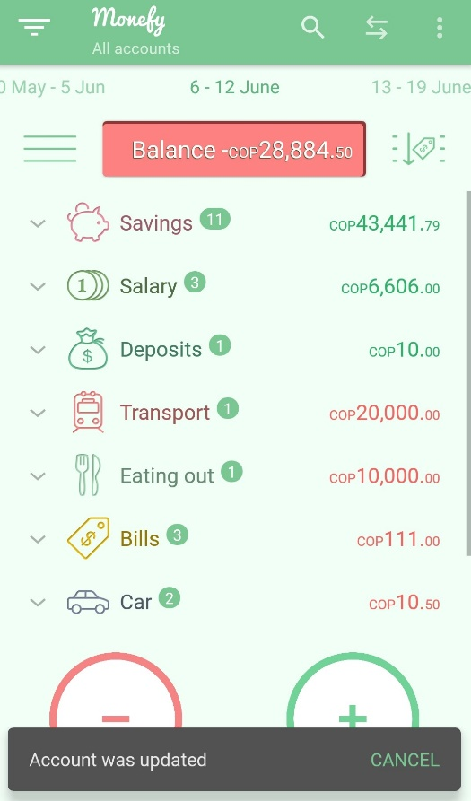

1. **Scenario:** Translate the app

***Title:*** Verify that the ‘Monefy’ app is translated when a language is selected.

***Steps:***

**Given** the user access to the ‘Monefy’ app

**When** the user selects the ‘settings’ option

**And** selects any language on the @language option

**Then** the app should translate into the language selected

***Current result:*** The app isn’t translated when a language is selected.

***Expect Result***: The app should translate when a language is selected.

@language: French, Portuguese.

**Assigned to:** Dev 2

**Attachment**:

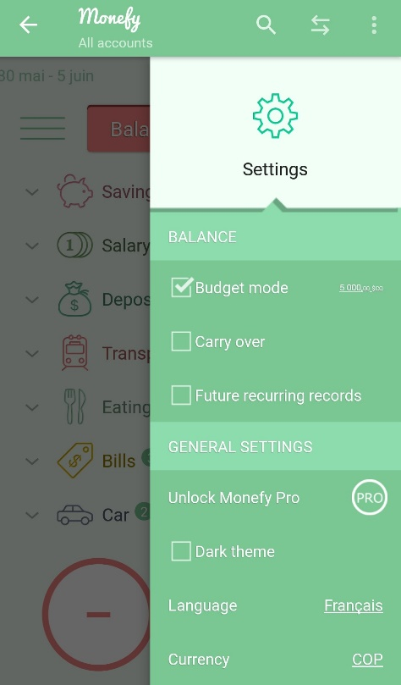 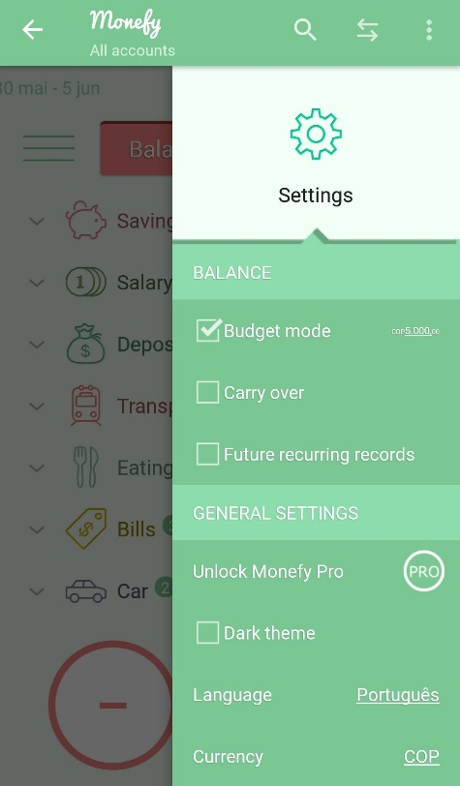

1. **Scenario:** ‘Income’ and Expense’ icons

***Title:*** Verify that ‘Income’ and Expense’ icons aren’t disappeared when the Portuguese language is selected.

***Steps:***

**Given** the user access to the ‘Monefy’ app

**When** the user selects the ‘settings’ option

**And** selects the Portuguese language on the ‘language’ option

**Then** ‘Income’ and Expense’ words change by ‘+’ and ‘-’ signs respectively

***Current result:*** ‘Income’ and Expense’ words change by ‘+’ and ‘-’ signs respectively when the Portuguese language is selected.

***Expect Result***: ‘Income’ and Expense’ icons shouldn’t disappear when the Portuguese language is selected.

**Assigned to:** Dev 1

**Attachment**:

 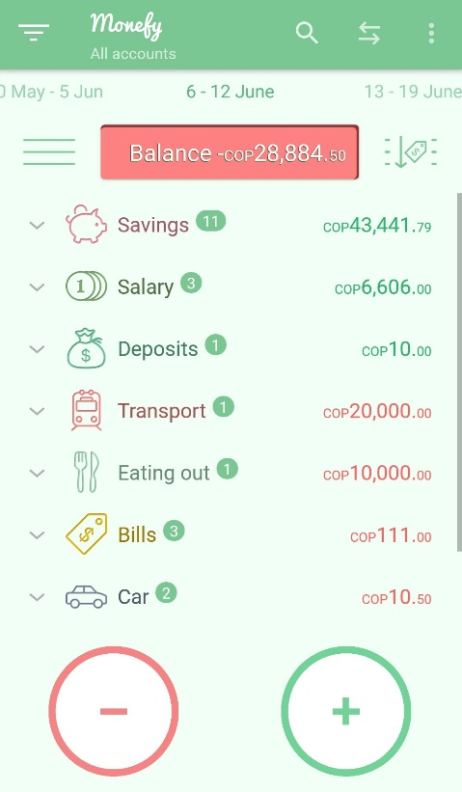

1. **Scenario:** ‘Future recurring records’ label

***Title:*** Verify that the ‘Future recurring records’ label is translated when the Spanish language is selected.

***Steps:***

**Given** the user access to the ‘Monefy’ app

**When** the user selects the ‘settings’ option

**And** selects the Spanish language on the ‘language’ option

**Then** ‘Future recurring records’ label should translate when the Spanish language is selected

***Current result:*** ‘Future recurring records’ label isn’t translated when the Spanish language is selected.

***Expect Result***: ‘Future recurring records’ label should translate when the Spanish language is selected.

**Assigned to:** Dev 1

**Attachment**:

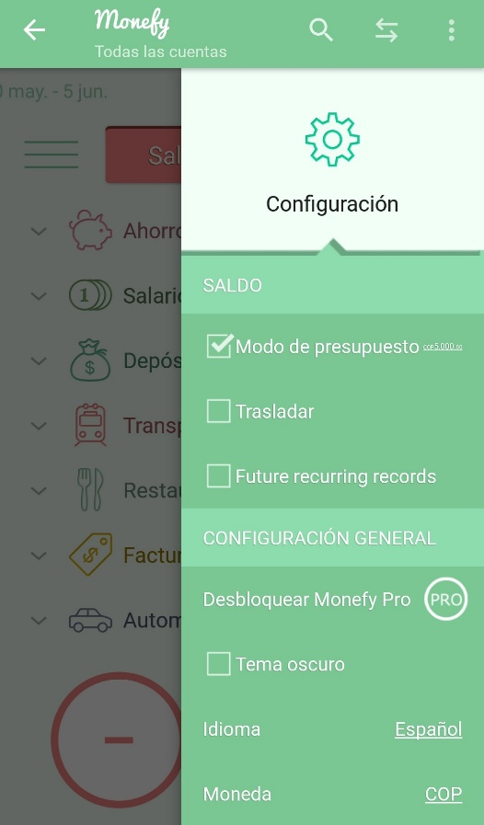

1. **Prioritization:** The first areas that I tested were income, expense and some all strongly related to business in order to understand functionality, how works and what I can expect based on the quicks test. After that, I did some quick exploratory tests of filters, languages and texts.

**Time to spend for each character:**

Charter 1: 30 minutes

Charter 2: 30 minutes

Charter 3: 25 minutes

Charter 4: 25 minutes

Charter 5: 20 minutes

Charter 6: 10 minutes

Charter 7: 5 minutes

1. **Risks:** For this type of application, I would mitigate project risks (technical) and product risks (bad features, functionalities).